Co-Chair  Vernon Sykes, Representative  34th House District | 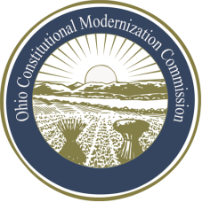 | Co-Chair  William G. Batchelder, Speaker  69th House District
Ohio Constitutional Modernization Commission

Finance, Taxation, & Economic Development

- Art. VIII (Public Debt and Public Works)

- Art. XII (Finance and Taxation)

- Art. XIII (Corporations)

- Tax Reform

- Statewide Intrastate Economic Development

